Study of the vegetative cover of the natural monument "Mulin Dol" stow (Bol'shechernigovsky District, Samara Oblast, Russia)
T M Lysenko^{1,2} and A V Ivanova²
¹ General Geobotany Laboratory, Komarov Botanical Institute RAS, St.-Petersburg, Russia
² Samara Federal Research Center RAS, Institute of the Ecology of the Volga Basin RAS, Togliatti, Russia

E-mail: abc000@mail.ru
Abstract. The "Mulin Dol" stow is a natural monument of regional significance located in the Samara Oblast (Russia). ……...
- Introduction
Text, text. First paragraph without indentation…...
The second and next paragraphs with indentation. Referances - in square brackets in order of mention [1].
- Materials and Methods
Text, text. First paragraph without indentation…...
The second and next paragraphs with indentation. Referances - in square brackets in order of mention [2-5].
- Results and Discussion
Text, text. First paragraph without indentation…...
The second and next paragraphs with indentation. Referances - in square brackets in order of mention [2-5]. Judging by the vertical distribution of abiotic factors and values of general and meromictic stability (tables 2, 3, figure 2),

Table 1. Dominant families of compared floras.
Physico-geographical region | Irgiz |  |  | Sok
Stow | - | Mulin Dol | Gryzly | -
Botanical-geographical zone | steppe | steppe | steppe | forest-steppe
Number of species | 770 | 311 | 352 | 1154
Family | Ast (16.2) | Ast (18.8) | Ast (17.2) | Ast (15.8)
Family | Poa (9.4) | Poa (11.0) | Poa (11.5) | Poa (8.9)
Family | Fab (7.0) | Fab (7.8) | Fab. Chen (7.5) | Fab (6.6)
Family | Brass (5.1) | Lam (5.5) | Brass (6.3) | Ros (4.8)
Family | Ros (4.8) | Brass (5.2) | Ran. Ros (4.0) | Brass (5.1)
Family | Chen (4.7) | Scr.Api (4.8) | Api (3.7) | Lam.Car (3.9)
Family | Scr (4.0) | Car. Ros (3.6) | Lam (3.5) | Cyp (3.6)
Family | Lam (3.9) | Chen (2.9) | Scr (3.2) | Scr (3.6)

Table 2. Morphometry of Oswaldocruzia filiformis males
Charac-ters ª | A. fragilis ^{b} (11) |  | L. agilis ^{b} (20) |  | Z. vivipara ^{c} (10) |  | N. natrix ^{b}(3) |  | V. berus ^{b} (3)
Charac-ters ª | mean | min–max | mean | min–max | mean | min–max | mean | min–max | mean | min–max
BL | 8.51 | 7.75–9.50 | 7.61 | 6.65–9.25 | 7.53 | 6.90–8.25 | 8.79 | 8.50–9.16 | 8.16 | 7.22–8.75
BW | 0.157 | 0.134–0.185 | 0.144 | 0.118–0.181 | 0.143 | 0.125–0.161 | 0.125 | 0.118–0.130 | 0.159 | 0.145–0.173
LV | 0.080 | 0.073–0.083 | 0.081 | 0.071–0.089 | 0.078 | 0.069–0.085 | 0.078 | 0.076–0.081 | 0.076 | 0.075–0.077
WV | 0.041 | 0.035–0.049 | 0.043 | 0.037–0.049 | 0.042 | 0.035–0.047 | 0.038 | 0.037–0.039 | 0.040 | 0.039–0.041
OL | 0.395 | 0.354–0.433 | 0.384 | 0.354–0.417 | 0.389 | 0.370–0.409 | 0.466 | 0.448–0.489 | 0.453 | 0.437–0.472
TL | 0.130 | 0.129–0.136 | 0.129 | 0.114–0.142 | 0.130 | 0.118–0.139 | 0.130 | 0.122–0.138 | 0.113 | 0.106–0.118
SL | 0.218 | 0.197–0.236 | 0.208 | 0.188–0.232 | 0.200 | 0.185–0.212 | 0.217 | 0.200–0.232 | 0.212 | 0.208–0.217
NC | 36–39 |  | 37–45 |  | 39–41 |  | 34–36 |  | 40–45
ª abbreviations: BL – body length; BW – body width at the mid-length level; LV – length of cephalic vesicle; WV – width of cephalic vesicle; OL – oesophagus length; TL – tail length; SL – spicule length; NC – number of crests at the mid-body
^{b} Smolny National Park
^{c} Mordovia State Nature Reserve

…a map for the region was developed (figure 1).
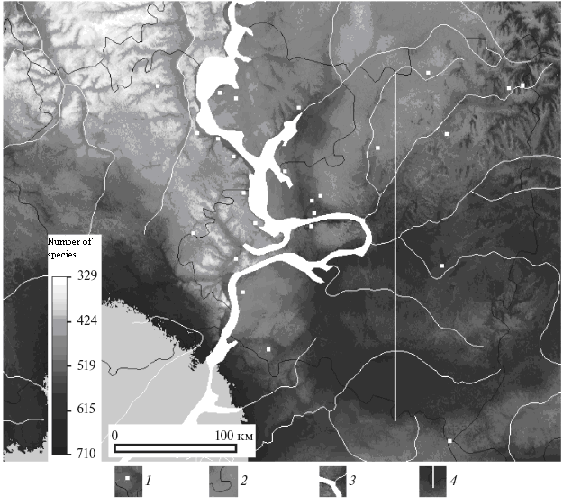 | Figure 1. Map of the spatial distribution of SR according to the model (1).  1 - centers of observation sites,  2 - boundaries of administrative regions, 3 - water bodies, 4 - transect
(a) (b) (c)
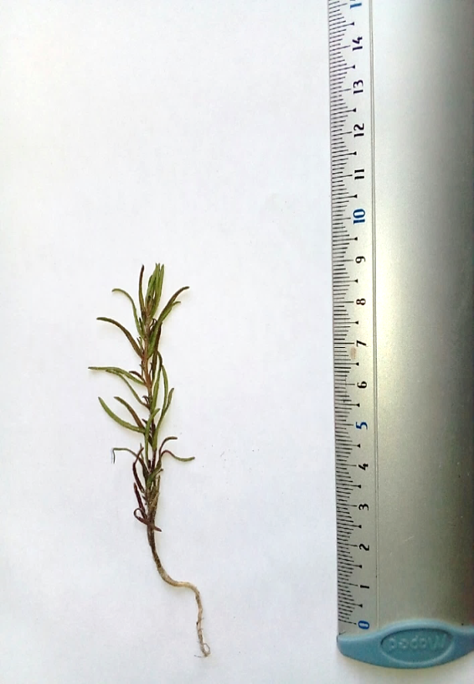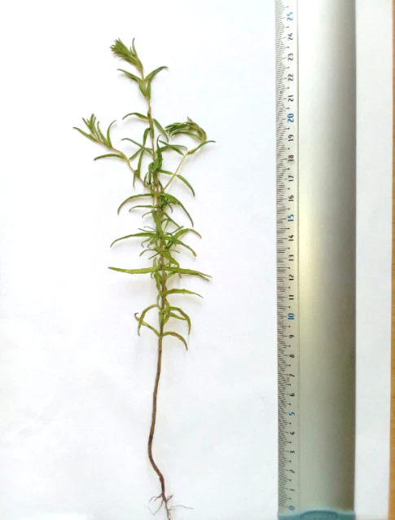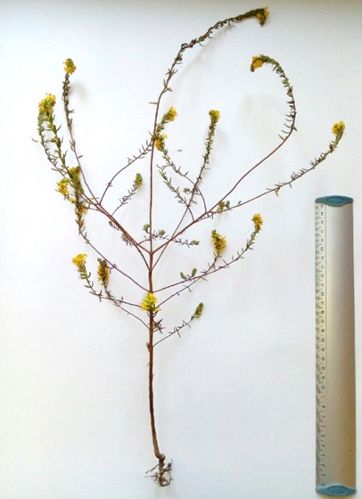
Figure 2. The early phase of the growing season (a), budding (b), and early flowering (c) of Odontites luteus (L.) Clairv. (Orobanchaceae); (a) — third decade of May and the first two decades of June, (b), (c) — from late June through mid-August.

- Conclusion
Text, text. First paragraph without indentation…...
The second and next paragraphs with indentation.

Acknowledgments
Text, text. Without indentation.
Funding. Without indentation.

References
- Specially protected natural areas of regional significance of the Samara region: materials of the state cadastre, and the second building 2018 Ministry of forestry, environmental protection and nature management of the Samara Oblast, comp. A S Pazhenkov (Samara: OOO "Laboratory Ecoton")
- Physical and geographical regionalization of the Middle Volga region 1964 ed. A V Stupishin. (Kazan: Publishing house of Kazan University)
- Kuzovenko O A, Korchikov E S and Popova D S 2012 Rare species of plants, lichens and lepidoptera of the “Mulin Dol” stow” natural monument (Bolshechernigovsky district of the Samara Oblast) Bulletin of the Samara Scientific Center of the Russian Academy of Sciences. Vol. 14 (1(8)) pp 2151-2154.
- Ilyina V N, Ilyina N S and Mitroshenkova A E 2006 Kopeechnik Razumovskogo in the Samara Syrtov Trans-Volga region Questions of general botany: traditions and prospects: mater. int. scientific. conf. (Kazan.) Part 2. pp 292-294.
- Kuzovenko O A and Plaksina T I 2009 “Gryzly” stow is a unique steppe natural monument of the Samara Oblast Bulletin of Samara State University 8 (74) 170-199.
- Lysenko T, Mitroshenkova A and Kalmykova O 2012 Vegetation Database of the Volga and the Ural Rivers Basins Biodiversity & Ecology 4 420-421.
- Mucina L et al. 2016 Vegetation of Europe: Hierarchical floristic classification system of vascular plant, bryophyte, lichen, and algal communities Applied Vegetation Science 19 (S.1) 3-264.
- Thrane J-E, Kyle M, Striebel M, Haande S, Grung M, Rohrlack T and Andersen T 2015 Spectrophotometric Analysis of Pigments: A Critical Assessment of a High-Throughput Method for Analysis of Algal Pigment Mixtures by Spectral Deconvolution. PLoS ONE 10(9) e0137645
- Semenov D Yu 2004 Ecology of perch (Perca fluviatilis L.) in the Central part of the Kuibyshev reservoir. The author’s abstract dis.... Cand. Sc. (Ulyanovsk)

